Basic Conditions Statement

Bisley with Lypiatt
Neighbourhood Development Plan

January 2026

A Introduction

A1 Outline

A1.1 This Basic Conditions Statement demonstrates how the Bisley with Lypiatt Neighbourhood Development Plan (‘the Plan’ or ‘NDP’) meets the basic conditions set out in paragraph 8(2) of Schedule 4B to the Town and Country Planning Act 1990 as applied to Neighbourhood Plans by Section 38A of the Planning and Compulsory Purchase Act 2004.

A1.2 The qualifying body (Bisley with Lypiatt Parish Council) is required to produce this statement in line with regulation 15(1)(d) and regulation 22 (1)(e) of the Neighbourhood Planning (General) Regulations 2012 (as amended).

A1.3 This Basic Conditions Statement has been prepared with regard to the following guidance / legislation:

- The Planning Advisory Service ‘Guide for Councils: Meeting your legal requirements for Neighbourhood Plans’
- The relevant extracts from the National Planning Practice Guidance, and
- The relevant Acts and Regulations which pertain to Neighbourhood Development Plans.

B Legal Requirements

This part of the Basic Conditions Statement confirms that in the view of Bisley with Lypiatt Parish Council, the Bisley with Lypiatt Neighbourhood Development Plan meets the legal requirements for a Neighbourhood Development Plan.

B1 The plan is being submitted by a qualifying body

B1.1 The Bisley with Lypiatt Neighbourhood Development Plan is submitted by the qualifying body – Bisley with Lypiatt Parish Council.

B2 What is being proposed is a Neighbourhood Development Plan

B2.1 The Bisley with Lypiatt Neighbourhood Development Plan relates to planning matters (the use and development of land) and has been prepared in accordance with the statutory requirements and processes set out in the Town and Country Planning Act 1990 (as amended by the Localism Act 2011) and the Neighbourhood Planning Regulations 2012.

B3 The proposed Neighbourhood Development Plan states the period for which it is to have effect

B3.1 The Bisley with Lypiatt Neighbourhood Development Plan specifies the time period for which it is to have effect as 2025-2040.

B4 The policies do not relate to excluded development

B4.1 The Bisley with Lypiatt Neighbourhood Development Plan proposals do not deal with county matters (mineral extraction and waste development), nationally significant infrastructure or any other matters set out in Section 61K of the Town and Country Planning Act 1990.

B5 The proposed neighbourhood plan does not relate to more than one neighbourhood area and there are no other neighbourhood development plans in place within the neighbourhood area

B5.1 The Bisley with Lypiatt Neighbourhood Development Plan proposals relate to the Bisley with Lypiatt Neighbourhood Area and to no other area. There are no other neighbourhood plans relating to this neighbourhood area.

B5.2 The Bisley with Lypiatt Neighbourhood Area was designated 25th July 2019. The Neighbourhood Area boundary is shown in Appendix 1 to this Statement and within the Bisley with Lypiatt Neighbourhood Development Plan.
C Basic Conditions

This part of the Basic Conditions Statement confirms that in the view of Bisley with Lypiatt Parish Council, the Bisley with Lypiatt Neighbourhood Development Plan meets all of the basic conditions required for a Neighbourhood Plan.

C1 Have regard to national policy and advice contained in guidance issues by the Secretary of State

C1.1 The Bisley with Lypiatt Neighbourhood Development Plan has been prepared under the December 2024 version of the National Planning Policy Framework (NPPF) which sets out the planning policies for England, together with the National Planning Practice Guidance (NPPG). Table 1 below briefly summarises how the national policies and guidance have been taken into account for each planning policy in the Bisley with Lypiatt Neighbourhood Development Plan. This approach follows the format employed by Arundel District Council in their Basic Conditions Statement, as referenced in Planning Aid Guidance as good practice.

Table 1- NDP Policies regard to National Planning Policy and Guidance

Planning Policy Title | Key National Policies | Commentary
Landscape
BWL L1  Landscape Character | NPPF Paras: 135, 187 (a&b) | Drawing on Local Landscape Assessment this policy reinforces NPPF goals of protecting and enhancing local landscapes.
BWL L2  Important Local Views | NPPF Paras: 135, 187 (a&b) | Seeks to protect important views and vistas both within the developed area and the wider landscape. This helps to achieve well designed places in conformity with NPPF para. 137 while also serving to protect valued landscapes in line with NPPF para. 187.
BWL L3 Local Green Spaces | NPPF Paras: 96(c), 103, 106, 107, 108  NPPG: Open space, sports and recreation facilities, public rights of way and local green space.  Environmental Improvement Plan, DEFRA, 2023 | L3 designates and protects demonstrably special Local Green Spaces safeguarding them against development except in very special circumstances. Green spaces have been considered against NPPF para 106 and assessed to ensure they meet all the criteria laid out in NPPF para.107.  The Environmental Improvement Plan sets out a national objective for everyone to live within 15 minutes’ walk of a green or blue space. By designating Local Green Space, this policy contributes to this national objective.
Wildlife
BWL W1Wildlife | NPPF:  8(c) 192 (a) | The policy plans positively to preserve and protect the rich wildlife of the Neighbourhood Area.
Policy BWL W2 Biodiversity and Nature Recovery | NPPF:  8(c) (Achieving sustainable development) 162,192  NPPG: Biodiversity net gain  Environment Act 2021  Environmental Improvement Plan, DEFRA, 2023 | The policy plans positively to preserve and protect habitats and biodiversity in the Neighbourhood Area.
Policy BWL W3 Dark Skies and Lighting Schemes | NPPF:  132 (Achieving well-designed places), 187 (b/d) 192 (b) (Conserving and enhancing the natural environment)  Environment Act 2021 | Dark night skies are one of the special qualities of the area that the Plan has identified (in accordance with para 132) that benefit local wildlife (187.b/d) para 192.b) and seeks to protect.
Settlement Pattern, Development Form Housing and Design
BWL SD1  Design and Development | NPPF Para.: 131, 132, 133, 134 (Achieving well-designed places)  National Design Guide National Model Design Code | This policy is in accordance with the aims of chapter 12 of the NPPF. The policy seeks to support development to be well-designed in response to valued local characteristics and distinctiveness (NPPF para 131, 132,133, 134) based on locally specific evidence in the Neighbourhood Plan.
BWL SD2  Meeting Local Housing Need | NPPF:  8b (Achieving sustainable development), 63, 64, 65  NPPG: First Homes, Para. 001 | The policy aims to add the local housing needs detail at the level of the neighbourhood area to increase the effectiveness of delivering the right types of housing to help local people secure a home that meets their needs, whether through open market or through subsidised pathways (paras. 63 / 64) and community led development that delivers affordable housing in our rural parish (para 65).
Local Heritage
BWL LH1  Non-Designated Heritage Assets of Local Heritage Significance | NPPF:  202, 216  PPG: Historic Environment, Para. 040 | This policy enables the identification of heritage assets of local historic value (para. 202), where their significance is taken into account in any proposal to avoid or minimise harm to the building (para. 216) and sets out a positive local level strategy for the conservation and enjoyment of non-designated, locally valued heritage assets.
Highways, Sustainable Transport and Movement
BWL HT1  Getting Around by Bus, Bike and on Foot | NPPF Paragraphs:  8 (Achieving sustainable development) 96(c), (Promoting healthy and safe communities) 109(e), 111(d), (Promoting sustainable transport) | The policy supports development that protects and enhances public rights of way and other key walking and cycling routes through and beyond the parish to enable and support healthy lives where walking and cycling becomes more of an option in the future in the Parish.
Climate Change Resilience and Energy
BWL CC1  Retrofitting Existing Buildings to Improve Energy Efficiency | NPPF Paragraphs:  7, 8 (Achieving sustainable development), 161, 167 (meeting the challenge of climate change, flooding and coastal change). | This policy is an important aspect of the ways in which the Parish is taking a proactive approach to mitigating and adapting to climate change (para 162) locally, and supports proposals that seek to improve the efficiency and resilience of existing buildings in the Parish (para 167).  Policy CC1 also supports the provision of new small scale domestic renewable generation which again is in conformity with the NPPF’s aim to transition to a low carbon future.
BWL CC2  Renewable or Low Carbon Energy Generation in Bisley with Lypiatt | NPPF Paragraphs:  7, 8 (Achieving sustainable development), 161, 165 (meeting the challenge of climate change, flooding and coastal change).  NPPG  Renewable and low carbon energy: Paragraphs 001 - 033 | Chapter 14 of the NPPF clearly sets out that plans should support the transition to a low carbon future.  This contributes to increased resilience to the challenges of climate change and the transition to a low carbon future by supporting the provision of sensitive small scale renewable energy generation, where it does not impact on our sensitive landscape, within the plan area.
Economy
BWL E1  Existing and new Businesses | NPPF Para: 88, 89 (Supporting a prosperous rural economy) | In conformity with NPPF paragraphs 88 and 89, this policy E1 seeks to create an environment which is supportive of local business’s needs.
BWL E2  Home Working | NPPF Para: 88, 89 (Supporting a prosperous rural economy) | Policy E2 supports proposals for development that would allow for increased provision of working from home and/or from within the parish.

C2 Contributes to the achievement of sustainable development

C2.1 The below approach follows the format employed by Broughton Astley Parish Council in their Basic Conditions Statement, as referenced in Planning Aid Good Practice Guidance.

C2.2 The key ways that the Bisley with Lypiatt Neighbourhood Development Plan will help to contribute to meeting the objectives of sustainable development are detailed below:

- The Neighbourhood Plan contains policies which relate to the environmental, social and economic aspects of the Parish (Policies: ALL)
- The Neighbourhood Plan seeks to set out a coherent local strategy for
the development of Bisley with Lypiatt Parish: considering housing, employment, recreation, and community facilities. [Policies: L3 / SD1, SD2 / HT1)
- The Neighbourhood Plan supports the protection and enhancement of environmental and historic assets. [Policies: L1, L2, L3 / W1, W2, W3 / LH1 / CC1, CC2)]
- The Neighbourhood Plan supports the protection and enhancement of local facilities and infrastructure. [Policies: HT1 / E1, E2)
- The Neighbourhood Plan is positive and proactive. It seeks to shape and direct housing, employment and retail development to the most appropriate locations in line with national policy considerations. [Policies: SD1, SD2 / E1, E2)

C3 Is in general conformity with the strategic policies contained in the Development Plan for the area

C3.1 The local policy which applies to the Bisley with Lypiatt Neighbourhood Development Plan Area can be found in the Stroud District Local Plan (adopted November 2015).

C3.2 The new Stroud District Local Plan Review was submitted for examination on 25th October 2021. The latest update on the examination is that the Inspectors recommend the withdrawal of the Local Plan Review. Stroud District Council have responded (letter uploaded 11.25.2025) to set out reasons why they disagree with that conclusion and do not intend to withdraw. They request further hearing sessions with the goal of enabling the updated evidence provided by the Council to be fully considered. As the Local Plan review is at such an advanced stage, and although the outcome continues to be uncertain, the Neighbourhood Plan has taken it into account during Plan preparation. Therefore, reference is made within Table 2 to the emerging draft policies (SDLP(d)).

C3.3 The qualifying body considers that Bisley with Lypiatt Neighbourhood Development Plan is in general conformity with the strategic policies contained in the current adopted Development Plan for the area, and with the emerging Local Plan Review Policies. This is outlined in Table 2 below.

Table 2 – NDP Policies general conformity with the Strategic Development Plan Policy Stroud District Local Plan (SDLP) and SDLP(d)
Planning Policy Title | Key Strategic Development Plan Cross Reference | Commentary
Landscape
BWL L1  Landscape Character | SDLP  ES7 Landscape character  ES8 Trees, hedgerows and woodlands  SDLP(d)  ES7, ES8 | This policy draws on local landscape character evidence to provide a more locally specific policy to complement and reinforce Delivery Policy ES7 and ES8.
BWL L2  Important Local Views | SDLP  ES7 Landscape character  SDLP(d)  ES7 | This policy seeks to protect important views and vistas both within the developed area and the wider landscape and is therefore in conformity with, and supports the delivery of Delivery Policy ES7.
BWL L3 Local Green Spaces | SDLP  ES6 Providing for biodiversity and geodiversity  ES13 Protection of existing open space  SDLP(d)  DHC6, DES2 | This policy protects important green spaces by designating them as Local Green Spaces. This is in conformity with Delivery Policy ES13 by protecting existing open space. Likewise, the policy is in conformity with, and supports the delivery of Delivery Policy ES6 by identifying specific biodiversity of local value.
Wildlife
BWL W1Wildlife | SDLP  ES6 Providing for biodiversity and geodiversity  ES8 Trees, hedgerows and woodlands  ES14 Provision of semi-natural and natural green space with new residential development  SDLP(d)  DCP1, ES6, ES8, DES2 | This policy is in conformity with Delivery Policies ES6, ES8 and ES14 by requiring that development integrates positively within, and has an overall positive impact on the natural environment.
Policy BWL W2 Biodiversity and Nature Recovery | SDLP  ES6, ES8, ES14  SDLP(d)  DCP1, ES6, ES8, DES2 | This policy is in conformity with Delivery Policies ES6, ES8 and ES14 by requiring that development integrates positively within, and has an overall positive impact on the natural environment.
Policy BWL W3 Dark Skies and Lighting Schemes | SDLP  ES6, ES7  SDLP(d)  DCP1, ES6, ES7 | This policy highlights a key characteristic of the parish that is valued by residents. It is in conformity with, and supports the delivery of ES6 with the link to biodiversity and landscape character.
Settlement Pattern, Development Form Housing and Design
BWL SD1  Design and Development | SDLP  CP4 Place Making  CP14 High quality sustainable development  ES10 Valuing our historic environment and assets  HC1 - Meeting small scale housing need within defined settlements  HC4 - Local housing need (exception sites)  SDLP(d)  CP4, ES10, ES12 | This policy is in conformity with Core Policy CP4 and delivery policy ES10 by referencing clear local design principles to build on national guidance and local level criteria listed in CP4. The policy is in conformity with CP14 in particular, directly supporting principles 5 and 9 of the policy.  The policy also supports the local delivery of policies HC1 and HC4.
BWL SD2  Meeting Local Housing Need | SDLP  CP8 - New housing development  CP9 - Affordable housing  SDLP(d)  CP4, ES10, ES12 | This policy links to local evidence on housing need, adding neighbourhood level detail to CP8 and CP9 in the Local Plan.
Local Heritage
BWL LH1  Non-Designated Heritage Assets of Local Heritage Significance | SDLP  CP4, ES10  SDLP(d)  CP4, ES10 | The identification of non-designation heritage assets is noted as an indicator for ES10 and adds local detail to this and CP4 as a key aspect of Place Making in the parish.
Highways, Sustainable Transport and Movement
BWL HT1  Getting Around by Bus, Bike and on Foot | SDLP  CP13 Demand management and sustainable travel measures  EI12 Promoting transport choice and accessibility  EI13 Protecting and extending our cycle routes  SDLP(d)  CP13, EI12 | This policy seeks to encourage and enable more active travel choices in the parish, it is therefore is in conformity with, and aids local delivery of Core Policy CP13 and Delivery Policy EI12 and EI13.
Climate Change Resilience and Energy
BWL CC1  Retrofitting Existing Buildings to Improve Energy Efficiency | SDLP  CP14  ES1 Sustainable construction and energy efficiency  SDLP(d)  DCP1, CP14, ES1 | Core Policy CP14 supports high quality sustainable development and lists ways in which this should be achieved including support for measures to minimise energy use and maximise renewable energy production. Delivery Policy ES1 requires maximisation of energy efficiency and integration of the use of renewable energy. This policy conforms with the LPA policies by supporting the retrofitting of existing buildings to both conserve energy and produce renewable energy.
BWL CC2  Renewable or Low Carbon Energy Generation in Bisley with Lypiatt | SDLP  ES2 Renewable or low carbon energy generation  SDLP(d)  DCP1, ES2 | Delivery Policy ES2 supports proposals for renewable and low carbon energy generation. Policy CC2 is in conformity with this by also encouraging renewable and low carbon energy generation in the plan area within the specific local constraints.
Economy
BWL E1  Existing and new Businesses | SDLP  CP11 New employment development  SDLP(d)  CP11, EI10  SDLP(d)  CP11, EI10 | In conformity with Core Policy CP11, this policy supports the provision of new start-up businesses and sets out considerations to take account of for the rural plan area.
BWL E2  Home Working | SDLP  CP11  HC8 Extensions to dwellings  SDLP(d)  CP11, HC8 | Policy E2 is in conformity with Delivery Policy HC8 by supporting proposals for extensions and adaptations of residential buildings for business uses incidental to the enjoyment of the dwelling. Policy E2 is also in conformity with Core Policy CP11 by supporting proposals that would support increased self-containment of settlements in terms of homes/jobs balance.

C4 Does not breach and is otherwise compatible with EU obligations

C4.1 The Neighbourhood Plan is compatible with EU obligations around human rights, habitat protection and environmental impacts. Specifically:

- Where Local Green Space designations and Locally Significant Heritage Assets are proposed, consultation and notification of inclusion in the NDP has occurred with the landowners concerned. Details of the consultation undertaken is outlined in the relevant appendicies to the Neighbourhood Plan.

- In addition, others who are affected by the proposals have been adequately consulted and have had the opportunity to comment on the proposals. The details of the consultation on the Plan are outlined in the Neighbourhood Plan Consultation Statement which can be found on the dedicated website for the Neighbourhood Plan: bisleyeastcombeoakridge-ndp2030.org.uk

- The Bisley with Lypiatt Parish Neighbourhood Plan group has prepared an evidence base which includes well documented evidence to underpin the policy approach. The evidence base can be found on the dedicated website for the Neighbourhood Plan: bisleyeastcombeoakridge-ndp2030.org.uk

- Stroud District Council, in line with the requirements of the European Directive 2001/42/EC, has an obligation to determine whether the Plan is likely to have significant environmental effects. To this end, Stroud District Council carried out a Strategic Environmental Assessment (SEA) screening on the draft Neighbourhood Plan, and prepared a SEA screening determination report for the Neighbourhood Plan in May 2025. The screening report states: ‘Following analysis of likely significant effects, Stroud District Council considers that the NDP is unlikely to have any significant effects on the environment. Therefore, the Council determines that Strategic Environmental Assessment of the Bisley with Lypiatt Neighbourhood Development Plan is not required.’ A copy of the SEA screening report can be accessed on the Stroud District Council website via this link.

C5 Does not breach the requirements of Chapter 8 Part 6 of the Conservation of Habitats and Species Regulations 2017(d)

C5.1 Stroud District Council also undertook a Habitat Regulation Assessment (HRA) screening on the draft Neighbourhood Plan in May 2025, to consider whether the Neighbourhood Plan would be likely to give rise to significant environmental effects on European Designated Sites. The screening report states: ‘Following this analysis, Stroud District Council considers that the NDP is unlikely to have any significant effects on European Designated Sites and can therefore be screened out from any requirement for further assessment under the Habitat Regulations.’ A copy of the HRA screening report can be accessed on the Stroud District Council website via this link.

Appendix

Map of designated Neighbourhood Plan Area (shown by the redline)

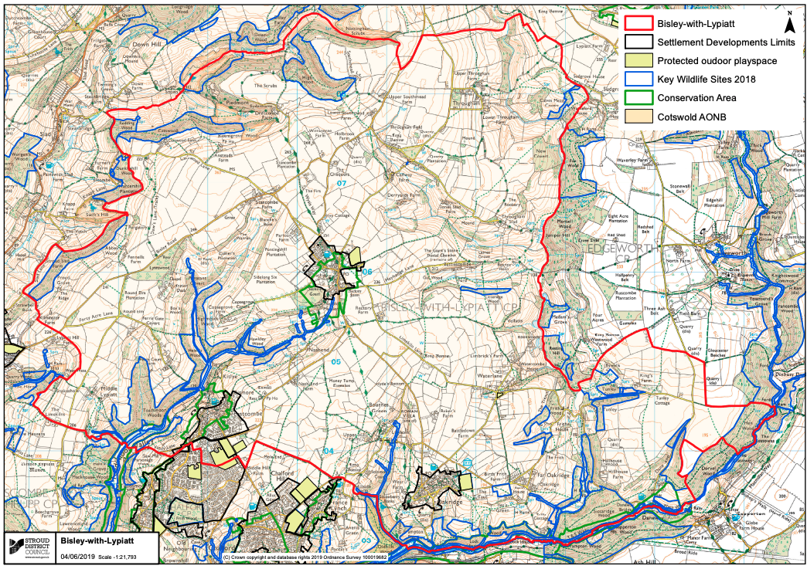

https://www.gov.uk/guidance/neighbourhood-planning--2#basic-conditions-for-neighbourhood-plan-to-referendum
https://www.local.gov.uk/sites/default/files/documents/legal-compliance-guide-pr-dc9.pdf
http://planningguidance.planningportal.gov.uk/
The Designation Certificate is available on the Stroud District Council website: https://www.stroud.gov.uk/media/f31lhhrg/bisley_designation_certificate.pdf
https://assets.publishing.service.gov.uk/media/67aafe8f3b41f783cca46251/NPPF_December_2024.pdf
https://www.gov.uk/government/collections/planning-practice-guidance
http://community21.org/downloads/Arundel%20Neighbourhood%20Plan_Basic%20Conditions%20S tatement_Nov%202013.pdf
www.stroud.gov.uk/media/pu3peplz/approaches-to-writing-a-basic-conditions-statement.pdf
https://www.stroud.gov.uk/media/mqjh01jn/bisley-with-lypiatt-sea-and-hra-screening-determination_redacted.pdf
https://www.stroud.gov.uk/media/mqjh01jn/bisley-with-lypiatt-sea-and-hra-screening-determination_redacted.pdf

