Bisley-with-Lypiatt
NEIGHBOURHOOD DEVELOPMENT PLAN
2024 - 2040

CONSULTATION STATEMENT

January 2026

1 Introduction

  - This document is a working draft version. The Consultation Statement is legally required to be submitted with the Neighbourhood Development Plan (also referred to as Neighbourhood Development Plan) as part of the next formal round of consultation. As such, this working draft version is not complete, but is being shared at this stage to show the consultation process that has been undertaken to date. The next version of this document will be completed after formal Regulation 14 consultation, to include Part B which will provide detail on the formal Regulation 14 process and comments received from consultees during this process.

  - This Consultation Statement has been prepared to fulfil the legal obligations of the Neighbourhood Planning Regulations 2012 in respect of the Bisley-with-Lypiatt Parish Neighbourhood Plan.

  - Section 15(2) of Part 5 of the Regulations requires that a Consultation Statement should:

- contain details of the persons and bodies who were consulted about the proposed Neighbourhood Plan.
- explain how they were consulted.
- summarize the main issues and concerns raised by the persons consulted.
- describe how these issues and concerns have been considered and, where relevant, addressed in the proposed Neighbourhood Plan (NDP).

Part A Gives an overview of the consultation events and activities that have led to the production of the Draft Bisley-with-Lypiatt Parish Neighbourhood Plan and ultimately the planning policies contained within it that aim to control and promote sustainable development in Bisley-with-Lypiatt Parish.
Part B Gives an overview and description of the pre-submission consultation, known as Regulation 14 that was undertaken over the period 13th October 2025 – 28th November 2025.
  - The purpose of Regulation 14 consultation was to ensure Parish residents, stakeholders and other interested parties had an opportunity to comment on a pre-submission draft of the neighbourhood plan. Those comments and issues raised will be included in this report, together with the Steering Group’s responses to those comments. Changes made to the plan following consideration of consultation responses will be outlined.

  - Throughout this document, references are made to the Neighbourhood Plan web-site where the results of the various consultation, surveys, and other applicable information may be found and viewed. (See also section 4.1) The web-site may be accessed by the following link:

Bisley Eastcombe Oakridge Parish | Neighbourhood Development Plan website

PART A

2 Our Approach to Consultation

2.1 Throughout the preparation stages of the Bisley-with-Lypiatt Parish Neighbourhood Plan, Bisley-with-Lypiatt Parish Council and the Neighbourhood Plan Steering Group have worked hard to engage local people on the progress of the Neighbourhood Plan, and also ask for people's views on key topics.
2.2 The Neighbourhood Plan Steering Group was formed in March 2019 after discussions were held at the Parish Council meeting which debated whether to update the existing Village Design Statement produced in 2010 or to produce a Neighbourhood Plan. Further discussions were held with representatives of Stroud District Council (Simon Maher) and GRCC (Barbara Pond) before the final decision to canvas the local population regarding the production of a Neighbourhood Plan.
2.3 Stroud District Council’s neighbourhood plan Link Officer, Simon Maher, and GRCC’s Barbara Pond have supported the Steering Group throughout the Plan preparation process.

3 Plan Preparation and Consultation

3.1 This section sets out details of how the community and other stakeholders as a whole were
engaged in the process of plan preparation.

3.2 Sequence of Events and Activities

3.2.1 The sections that follow describe what took place by type of event or activity. The chart below shows the sequence of activities and events (other than those described as ‘ongoing’ above).

Event/Activity | Date(s)
Public Meetings*  Eastcombe  Bisley  Oakridge | 10th September 2019  17th September 2019  24th September 2019
Household Survey* | November 2020
NDP Survey* | March 2021
Wildlife Survey* | March 2021
Autumn Show Presentations* | Aug/Sept 2022
Young People | September 2019 - ongoing
Employers/Landowners/Farmers | Summer 2024

*Full reports from these events are available on the NEIGHBOURHOOD PLAN website. A summary of key events and activities is below

- Public Meetings

Eastcombe, 10th September 2019 – 30 Attendees.
Bisley, 17th September – 32 Attendees.
Oakridge, 24th September – 20 Attendees.

The aim of these public meetings was to canvas the local population regarding the production of a Neighbourhood Plan. At the first meeting in Eastcombe a presentation entitled ‘A Closer Look at the Bigger Picture’ was given by Charles Landry. This presentation was recorded on video and presented at the subsequent meetings in Bisley and Oakridge. The presentation was designed to give context to a Neighbourhood Plan and detail the benefits. A copy of the presentation is on the Neighbourhood Plan website.
Following on from the discussions held at these meetings, to aid clarity it was agreed to split the NEIGHBOURHOOD PLAN into five categories covering Housing, Landscape, Wildlife, Mobility, Energy & Economy and the public responses can be summarized:
Housing – provision of affordable housing for young and older people (for downsizing) within the parish. New homes should be built to the highest possible ‘Eco’ standards.
Landscape – the natural landscape of the Cotswolds escarpment must be retained.
Wildlife – new and existing wildlife corridors must be maintained/enhanced and any new developments must not harm or impede the natural environment.
Mobility – emphasis should be placed on trying to reduce the dependency on petrol/diesel cars with greater reliance placed on reliable public transport and safer pedestrian/cycle facilities.
Energy and Economy – local green energy systems should be promoted and supported whilst local businesses should be encouraged to develop energy efficient practices.
Full details of the public comments and aspirations from these meetings were collated and can be found on the website
- Housing Needs Survey.

A Housing Needs survey was conducted by GRCC in November 2020 and the subsequent report issued in January 2021. The report can be accessed

Bisley-with-Lypiatt-2021-Housing-Needs-Survey-report-1.pdf

The survey was distributed to all 1012 postal addresses within the parish and 227 (22.4%) of households replied.

The main conclusion of this report details that within the parish 5 households require affordable rented housing, whilst 6 households require affordable home ownership.

- Wildlife Survey.

A wildlife survey appraisal was conducted by GWT, sent out to the community on 6th February with a closing date of 19th February 2021. Full details of their findings are given in the following document:

GWT-Bisley-With-Lypiatt-NDP-Wildlife-Appraisal-FINAL.pdf

Two of the key recommendations from this report were:

- The Parish contains key components of Gloucestershire’s ecological networks (Nature Recovery Network), particularly in the south along the Golden Valley, to the north adjoining the Slad Valley and along the Holy and Toadsmoor Brooks. There is strong community support for protecting, expanding and connecting wildlife-rich habitat in these areas.

- There is clear demand for improvements to green infrastructure, with the strongest support for

➢ Creating stepping-stones and corridors that connect ecological networks,
➢ A new accessible natural green space near to the main villages.
➢ Enhancing the biodiversity value of existing green spaces.

GWT also organised an online meeting on January 27th 2021 to discuss their findings and the implications. This meeting was attended by approximately 50 people.

- NDP Survey

The Steering Group organised a Parish wide NEIGHBOURHOOD PLAN survey completed in March 2021 covering all postal addresses in the parish. 311 responses (30.7%) were received and the results were analysed by GRCC. Full details can be found by accessing the following link:

https://bisleyeastcombeoakridge-ndp2030.org.uk/wp-content/uploads/2021/11/Bisley-with-Lypiatt-NDP-Survey-2021-questionnaire-report-percentages.pdf

- Autumn Show Presentations

Following on from the results of the surveys a set of Draft Policies was compiled by the Steering Group. It was decided to produce a series of Display Boards which could be set up at each of the village Annual Shows held in August and September 2022 so that the public response to these policies could be gained.

Responses from the public were collated and apart from a couple of cases there was wide support for the proposals. A copy of the proposals and further details of the responses may be found on the website. It should be noted that only people who lived within the Parish were asked to comment

- Local Employers, Landowners and Farmers

In May 2024 a short questionnaire was sent via e-mail to all the local businesses, farmers and landowners who either live or work within the Parish asking for their views on the Neighbourhood Plan. A copy of the questionnaire can be found at on the web-site. Responses were requested by 31st August 2024.

From the 98 e-mails sent only 8 responses were received and these mainly dealt with improving infrastructure etc. Full details are on the web-site.

- Young People
During 2019-2020 members of the Steering Group engaged with the Nature Group and the Gardening Group at Thomas Keble School. Over this period there was a particular workshop on Neighbourhood Plan issues in which the young people were engaged by an officer from GWT (Juliet Hynes) and the then Education Officer at the Royal Forestry Society, Georgia Spooner. The conclusion of these discussions was that by 2025 it is intended to have at least 50% of our farmland as ‘nature friendly’.

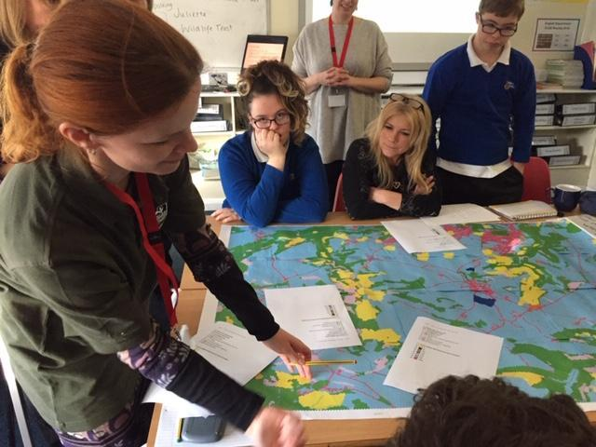

Work has continued between the Parish with TK school students through the Nature Club and now we are working on the Swift Project with another class, mapping migratory routes (international wildlife corridors if you like) to putting nesting boxes on the school buildings. Clearly different classes are involved as each year moves up the school.

On the 25th June 2024 members of the Steering Group visited TK school to hold discussions with a number of pupils from year groups 7,8,9, and 10 all of whom live within the parish. These discussions centred around three questions:
- What do you like about where you live?
- What would you change?
- What new things would you like to see?

The response to these questions may be found on the web-site: https://bisleyeastcombeoakridge-ndp2030.org.uk/
4. ONGOING ACTIVITIES
4.1 A dedicated website has been set up to share information on the process of the Plan drafting, promote the details of events and activities. The website also hosts Neighbourhood Plan webpages which contain consultation documents and details of the evidence gained. The website is updated regularly to include the latest information regarding the Neighbourhood Plan. It can be accessed via this link:
Bisley Eastcombe Oakridge Parish | Neighbourhood Development Plan

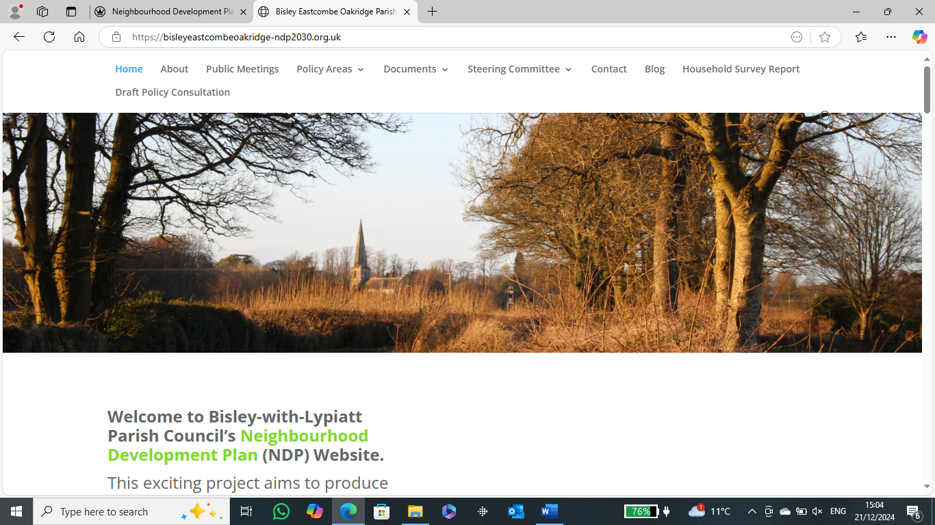
It should be noted that the Steering Group have decided not to use Social Media to publicise Neighbourhood Plan information etc.
Parish Newsletters
4.2 The 3 main villages of the parish are each served by Newsletters either monthly or bi-monthly, or quarterly. Articles relating to the NEIGHBOURHOOD PLAN especially regarding public consultations have been included in these publications.
Attending Local Events
4.3 There are local events and activities held regularly within the Parish which provide a diverse range of opportunities to engage with the public. These range from local cinemas to relaxation classes and other social activities (quiz evenings, gardening clubs etc.). Whenever possible, opportunities are taken to engage with the public on various Neighbourhood Plan issues and any significant points raised noted.

Part B

5. Regulation 14 – Pre-Submission Publicity and Consultation

Introduction

- The Neighbourhood Planning (General) Regulations 2012 states that before submitting a plan proposal to the local planning authority, a qualifying body (in this case Bisley-with-Lypiatt Parish Council) must:

- publicise in a manner that is likely to bring it to the attention of people who live, work or carry on business in the neighbourhood area
- details of the proposals for a Neighbourhood Plan
- details of where and when the proposals for a Neighbourhood Plan may be inspected
- details of how to make representations and
- the date by which those representations must be received, being not less than 6 weeks from the date on which the draft proposal is first publicised
- consult any consultation body referred to in paragraph 1 of Schedule 1 whose interests the qualifying body considers may be affected by the proposals for a Neighbourhood Plan and
- send a copy of the proposals for a neighbourhood to the local planning authority

- This section of the Consultation Statement will therefore outline the approach taken by the Steering Group to consult on the Draft Neighbourhood Plan at the Regulation 14 stage of the process.

Process

- Following a comprehensive review of the Draft Neighbourhood Plan and its associated evidence the Steering Group decided to submit the plan for Regulation 14 public consultation between October 13th 2025 and November 28th 2025, a period of 7 weeks.

Public Consultation

- Publicity posters advertising the consultation were produced (see below) and posted on the Parish Notice Boards and websites.

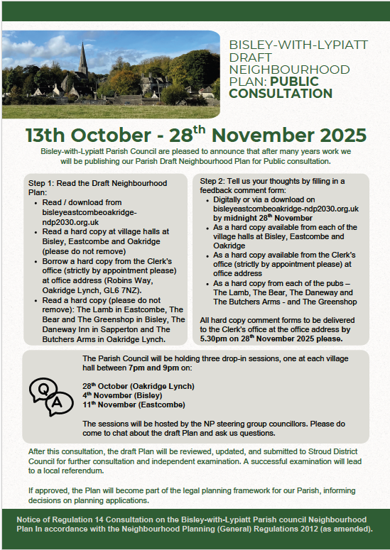

- Articles were placed in the 3 village magazines and the process was outlined at various meetings held by clubs etc throughout the parish (e.g. the Eastcombe Village Group meeting held 13th October 2025).

- In addition, a simple comment form was produced such that residents could submit their thoughts and comments on the plan. This could be done either on-line or by hard copy. A copy of the response form is attached in Appendix A. The Draft Neighbourhood Plan was uploaded onto the Parish and Neighbourhood Plan web-sites such that it could be viewed or down-loaded.

- Hard copies of the Neighbourhood Plan were produced such that they could be read by the public at the following locations:
- Bisley – Village Hall, The Bear Inn, The Green Shop.
- Eastcombe – Village Hall, The Lamb Inn.
- Oakridge – Village Hall, The Butchers Arms, The Daneway Inn.

- In addition, the Parish Clerk held several hard copies available for short term loan during the consultation period.

- Hard copies of the comment form were also placed in all the public locations detailed above.

- The Steering Group set up 3 public sessions in the village halls to allow residents to come and discuss the NEIGHBOURHOOD PLAN and its implications for the future of the Parish. These were held:

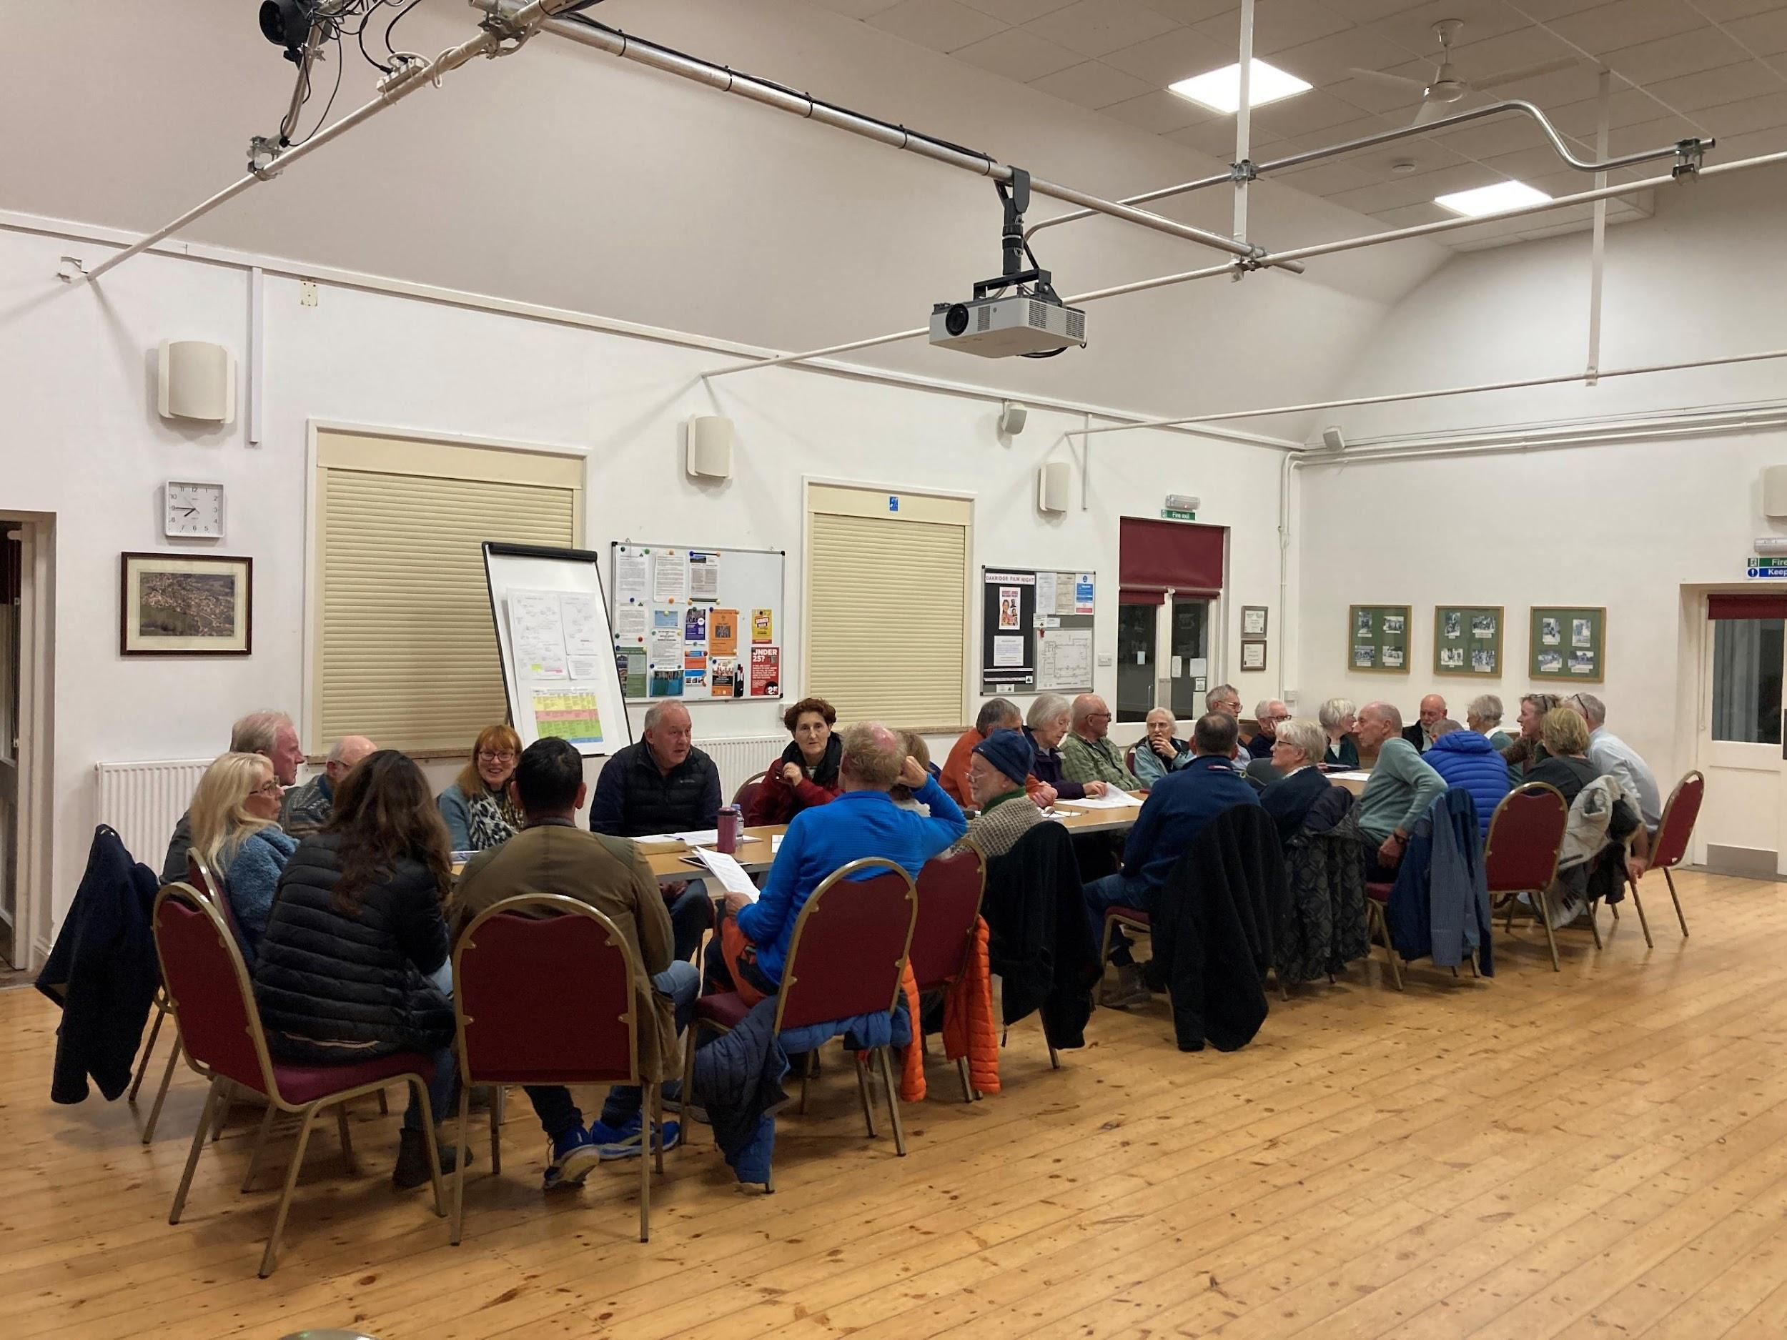
Oakridge Village Hall – 28th September 2025

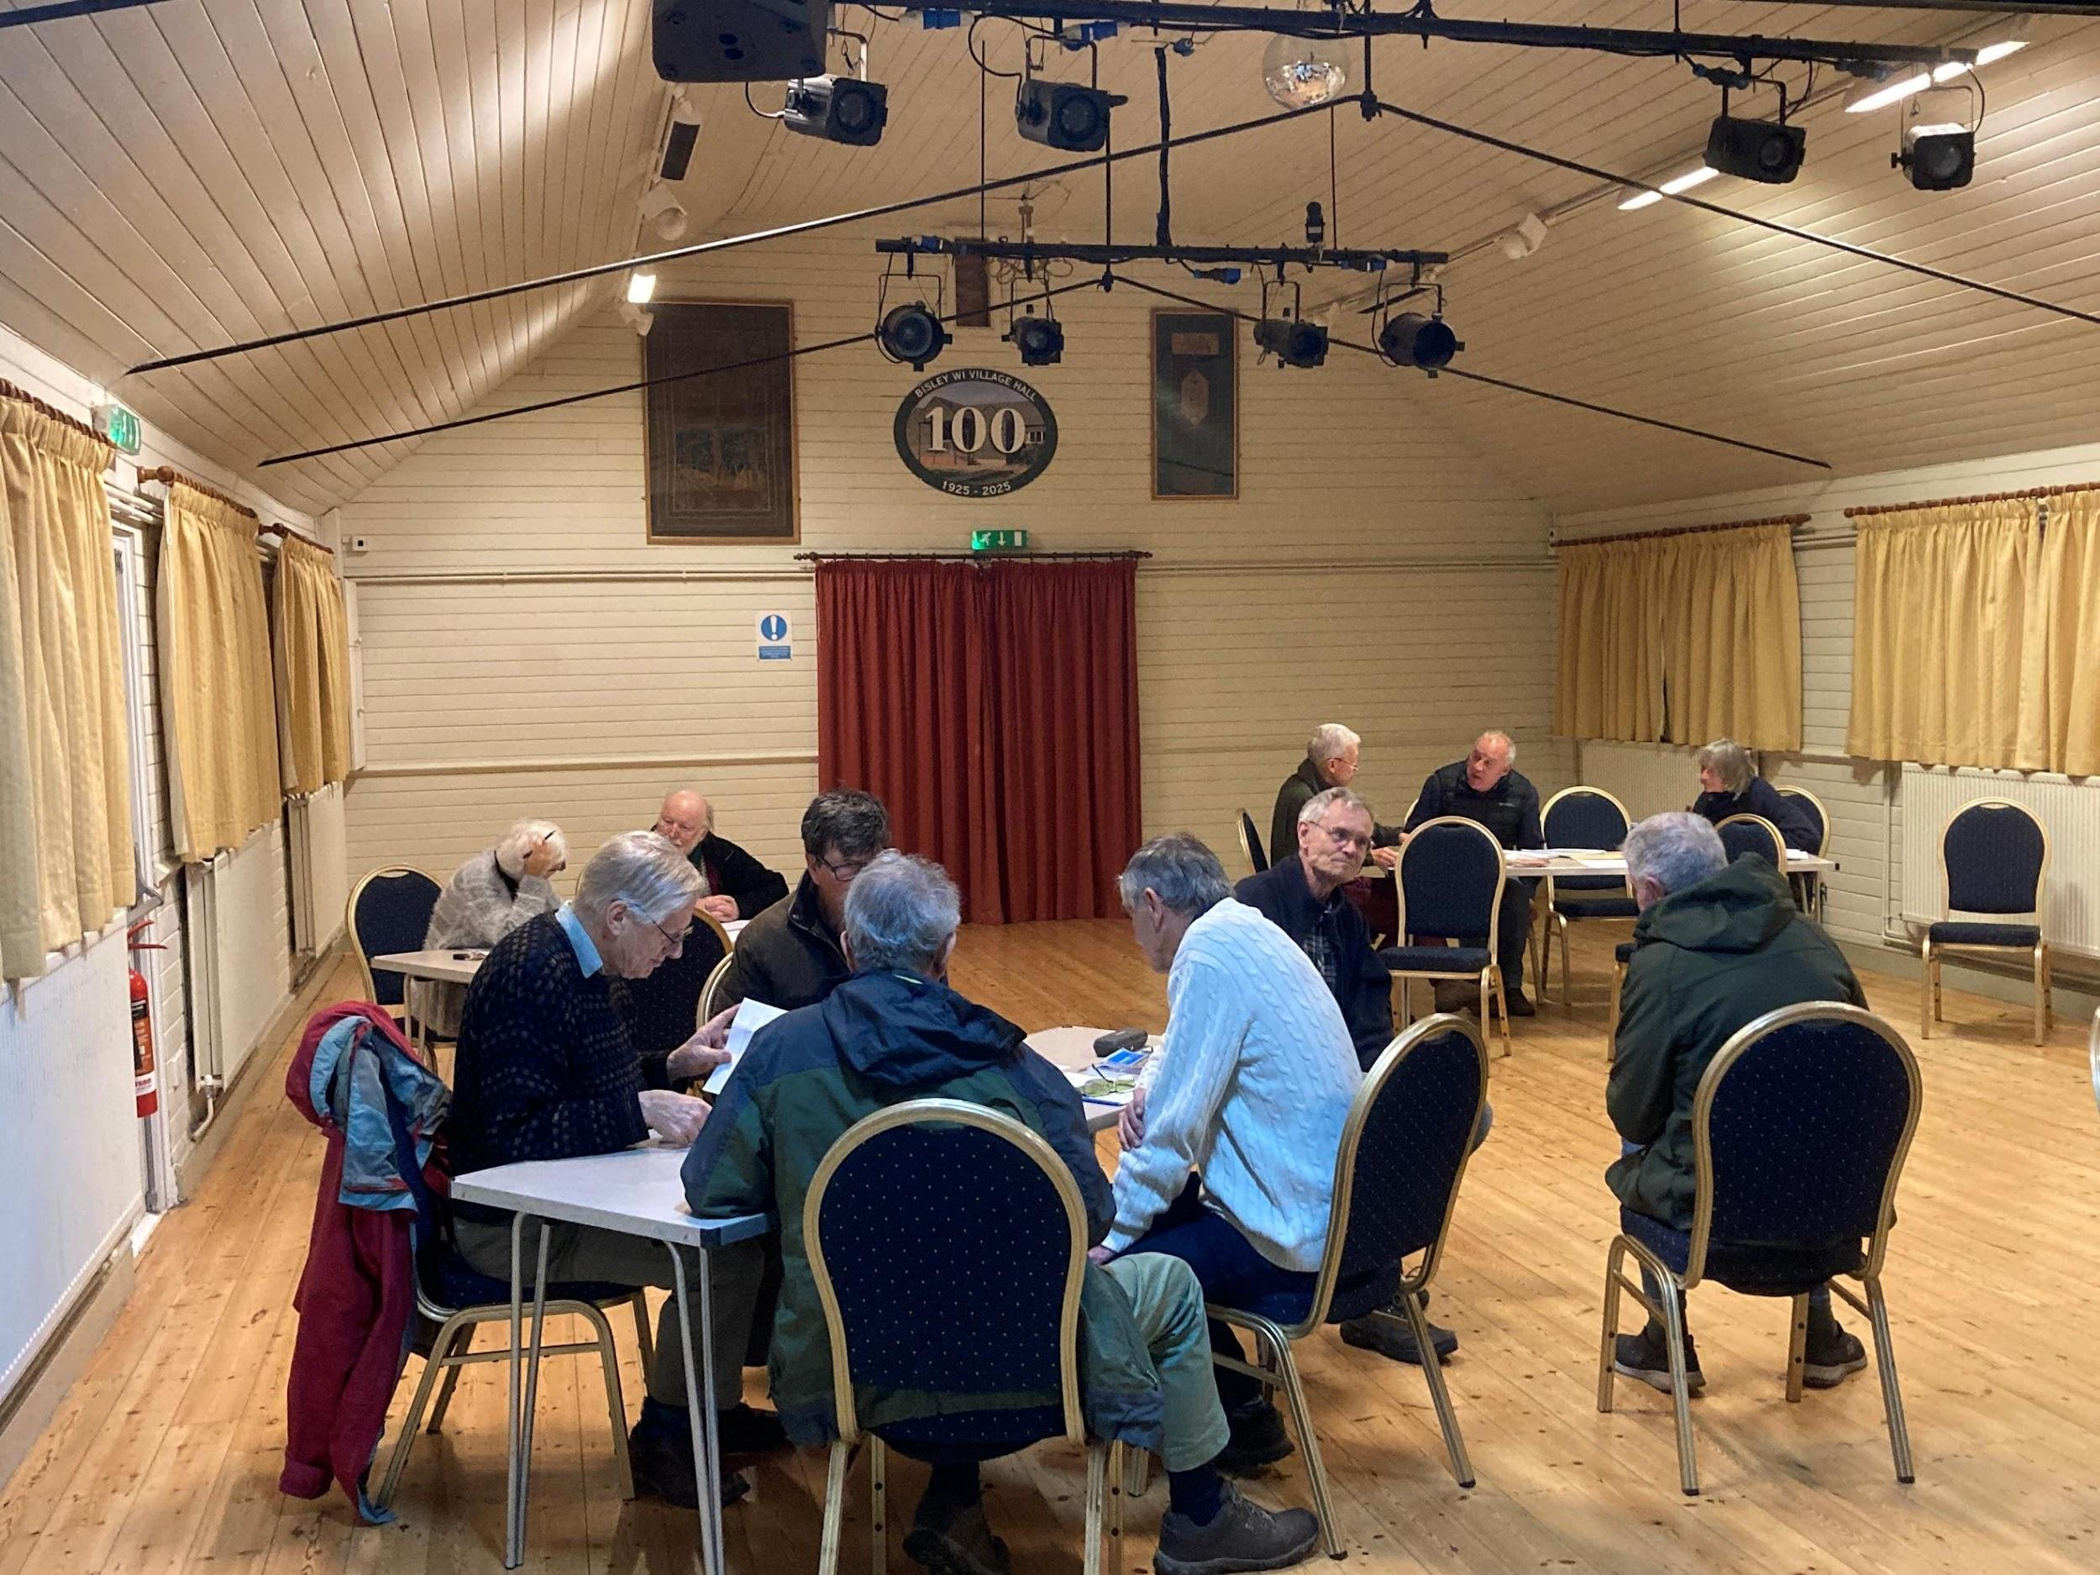
Bisley Village Hall – 4th November 2025

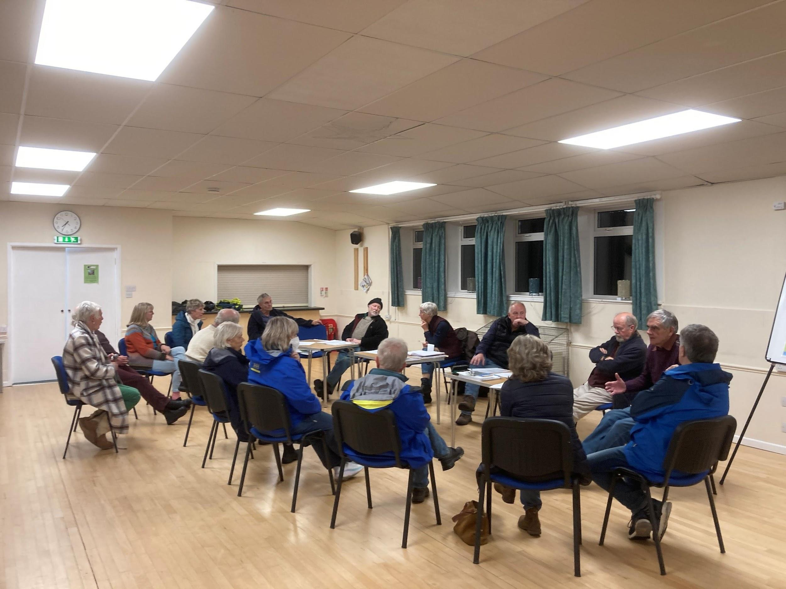
Eastcombe Village Hall – 11th November 2025

Statutory Bodies Consultation

- In accordance with the 2012 Neighbourhood Planning Regulations draft copies of the Neighbourhood Plan were sent to the appropriate authorities. A full list of the consultees can be found on the Neighbourhood Plan website together with any acknowledgement of replies received.

Consultation Response.

- One Hundred and Thirty Nine (139) individuals responded during the consultation period. Of these, the comments from each Ward were:

- Bisley Ward 63
- Eastcombe Ward 20
- Oakridge Ward 54
- Others 2.

- Responses were also received from statutory consultees and local organisations:
- Stroud District Council
- Gloucestershire County Council
- Gloucestershire Wildlife Trust
- Brimscombe and Thrupp Parish Council / Chalford Parish Council
- Stroud Chamber of Commerce
- Historic England (no specific comments but expressed support)
- Natural England (no specific comments)
- Environment Agency (no specific comments)
- Police (no specific comments)
- Active Travel (no specific comments)
- Wales & West Utilities (no specific comments)

- Community comments were collated and entered into an Excel Spreadsheet, a copy of which can be found on the Neighbourhood Plan website, and is appendix B to this Consultation Statement. All comments were addressed by the Steering Group and their responses to the comments are included in the Spreadsheet. The full set of responses from Statutory consultees is compiled as Appendix C to this report. A summary of the community comments, together with next steps was prepared for feedback to parish following the consultation – see appendix D.
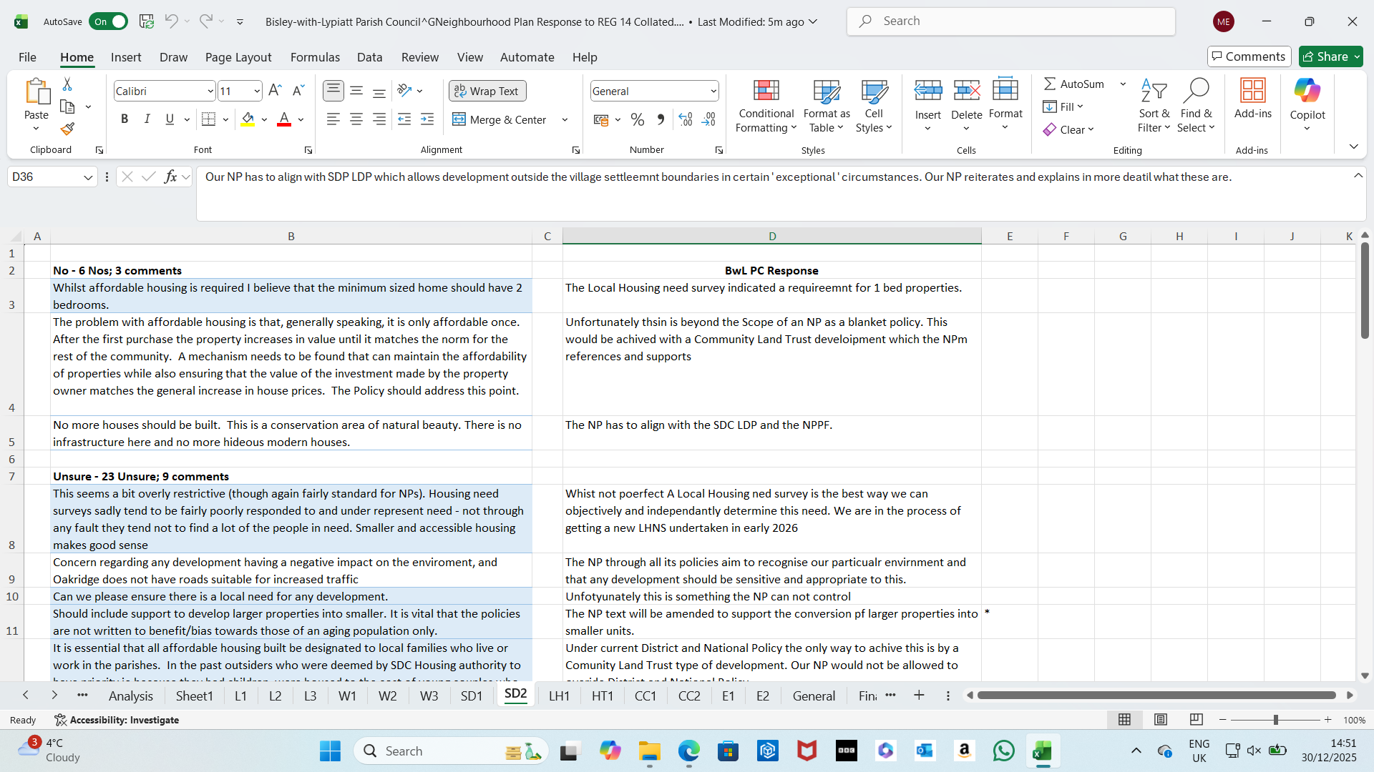

Above: Screenshot of the Excel Spreadsheet showing comments and responses to Policy SD2.

- All comments were reviewed and changes made to both the plan text and policies. A summary of the main policy changes resulting from these comments is given in the next few pages.

NOTES:

This table captures the key comments and subsequent changes to the Neighbourhood Plan following Regulation 14 consultation.

All comments have been logged in a spreadsheet / compiled which will be included as an appendix to this Consultation Statement.

All comments have been carefully considered, and where appropriate, amendments made to the draft Plan and evidence base for Regulation 15 submission to the Local Planning Authority. A summary of issues and subsequent changes are set out in the table below.

Text has been struck out example where necessary or added in red text.

Summary of points / issues raised at Regulation 14 Consultation | Changes made to Policies for Submission Plan
Introductory sections / Vision and Objectives
Policy BWL L1 Landscape Character
Overall support for this policy. Minor changes made in response to feedback. | b.ii Existing stone walls, trees, hedges, and other natural features will be retained as part of the scheme. Harsh edges of new development will be broken up with appropriate and adequate tree planting, ideally in advance of the development taking place. For preference, trees should be native and non-invasive.
Policy BWL L2 Important Local Views
No changes to the policy drafting, but in response to community feedback, further suggestions for views were reviewed and added: Eastcombe (view 23) and Bisley (views 24 - 30)
Policy BWL L3 Local Green Spaces
No changes to the policy drafting, but in response to community feedback, further suggestions for LGS reviewed and 1 space confirmed withdrawn (LGS2. Chestergate Allotments) 2 more spaces added as a result:
24. Junction of Fidges Lane and The Street
25. St Augustines Church – Garden of Rest

Overall 23 LGS in total included in the submission Plan.
Policy BWL W1Wildlife
Overview of issue and justification for change | Clause 1 omit the words ‘where possible’: Protects, and where possible, improves wildlife value.  Clause 4 omit the words ‘ where appropriate ‘at the end of the para.  Protects highway verges as wildlife corridors, and other wildlife corridors, where appropriate.
Policy BWL W2 Biodiversity and Nature Recovery
Overall support for this policy. Minor changes made in response to feedback on equine land use which is already captured in the first part pf the clause. Furthermore there is no supporting text to single out this type of land use or evidence to single it out in consultations in 2019 or responses in 2025. | Clause b point 1 :omit the words ‘ which would include recreational equine land use.’  - has a net detrimental impact on land in the core open habitat network or high priority for restoration which would include recreational equine land use;
Policy BWL W3 Dark Skies and Lighting Schemes
Overall support for this policy. No changes made.
Policy BWL SD1 Design and Development
Overall support for this policy. Minor changes made in response to feedback (minor changes also made to the design guidelines). | Clause b point 1 and 2 :omit the words ‘and other relevant documents.’  1.b It conserves and enhances the Parish’s built and natural environment having regard to the distinctive local character, and accords with the Design Guidelines set out in Schedule 1 of this Neighbourhood Plan and other relevant documents.  2.b it conserves and enhances the Parish’s built and natural environment having regard to the distinctive local character according with the Design Guidelines of this Neighbourhood Plan and other relevant documents
Policy BWL SD2 Meeting Local Housing Need
Overall support for this policy. Minor changes made in response to feedback. | Add a further final clause:  D. Proposals to sensitively split larger individual houses into smaller dwelling units will be supported. All smaller dwelling units created in this way must demonstrate adequate parking provision can be accommodated on site.
Policy BWL LH1 Local Non-designated Heritage Assets
Overall support for this policy. Non material changes made in response to feedback from Stroud District Council to ensure the policy is using correct planning terms. | DRAFT POLICY BWL LH1 Locally Significant Non-Designated Heritage Assets of Local Heritage Significance  1. The Plan identifies buildings, features and structures which are not listed nor in conservation areas, but are of local importance for their local heritage significance value as listed identified and detailed in appendix 3.  2. The effect of a Town Planning application on non-designated heritage asset or assets of local heritage significance should be fully taken into account when determining the application. Development proposals will be supported where they can demonstrate that the heritage significance and setting of our local heritage assets will be conserved and, where appropriate, enhanced. Proposals involving any harm to a local heritage asset or any potential loss of significance will be supported only where there is clear and convincing justification, set out in a Heritage Statement.  The effect of an Town Planning applications on any local non-designated heritage asset or assets of local heritage significance should be fully taken into account the significance of the identified Locally Valued Non-designated Heritage Assets should be taken into account when in determining the application. Development proposals will be supported where they can demonstrate that the heritage significance and setting of our local heritage assets will be conserved and, where appropriate, enhanced. Proposals involving any harm to a local heritage asset or any potential loss of significance will be supported only where there is clear and convincing justification, set out in a Heritage Statement.  In weighing applications that directly or indirectly affect a non-designated heritage asset of local values, a balanced judgement will be required having regard to the scale of any harm or loss and the significance of the heritage asset.
Policy BWL HT1 Getting Around by Bus, Bike and on Foot
Overall support for this policy. Minor changes made in response to feedback. | Second clause amended:  Development proposals should demonstrate how the effect of additional vehicular movement generated by the development will be mitigated to prevent human and wildlife disturbance, and protect safety and the highway capacity within the Parish.  Development proposals will be required to demonstrate that it will cause no adverse effect on the capacity and safety of the local highway network.  Cycle routes should, if feasible, meet the standard in DfT Cycle Infrastructure Design Guide LTN 1/20
Policy BWL CC1 Retrofitting Existing Buildings to Improve Energy Efficiency
General support for this policy, though community feedback highlighted some concerns. Changes made in response to feedback. | Second clause amended:  Proposals that help to increase resilience to climate change and secure a sustainable future for buildings in the Conservation Areas, listed buildings, historic buildings or non-designated heritage assets, will be supported where they satisfactorily demonstrate how the special characteristics of the individual heritage assets are preserved and where possible, enhanced or revealed.  Proposals that are sensitive to buildings in the conservation area, listed buildings and historic non-designated heritage assets will be supported, especially where they help to secure a sustainable future for the building.
Policy BWL CC2 Renewable or Low Carbon Energy Generation
Overall support for this policy. Minor changes made in response to feedback. | Proposals for renewable or low carbon energy schemes in the Parish will can be supported where they meet all the following criteria. That they:  - provide demonstrable community-scale benefit; and  - are sensitively sited in response to ecology, landscape and heritage setting; and,  - are integrated so that the energy generated can be supplied directly or virtually to domestic, business and other buildings in the Parish; or  - are fully or partly owned by BWL residents and businesses, with BWL residents given priority. This policy does not apply to solar panels placed on existing or proposed new buildings, or within the curtilage of such sites or owner promoted hydro- power on riparian sites.  - Are located such that they have no adverse impact on the landscape and visual amenity  - Are sensitively sited to protect ecology, wildlife, heritage assets and the natural environment on the site and in the locality  - Are small in scale  For community energy generation proposals the following additional criteria will also need to be met. That they:  4. Have the support of the community  5. Are led and controlled by the community for the benefit of the community
Policy BWL E1 Existing and new Businesses
Overall support for this policy. Minor changes made in response to feedback and Steering Group editing. | Changes made to clause 2:  - Support is subject to an assessment of the impact of the proposals. Severe impacts on the following areas will require appropriate mitigation:  - Residential amenities;  - The transport network and parking conditions;  - Biodiversity and the environment. Landscape and wildlife; and,  - Visual amenity and sensitivity of the Cotswold National Landscape and the conservation of local characteristics.  2. Proposals will be supported where it can be demonstrated that they:  - Are of a scale, layout, and design that is sensitive to the character of the surrounding area;  - Do not result in unacceptable harm to the residential amenity;  - Conserve or enhance the natural environment, including landscape character, biodiversity, and heritage assets;  - Provide safe and suitable access for all users and do not result in a severe impact on the local highway network or parking capacity;  - Prioritise the use of the conversion of existing redundant buildings where feasible.
Policy BWL E2 Home Working
Overall support for this policy. Minor changes made in response to feedback. | Omit last clause referencing the internet  Measures which would improve internet efficiency will be supported.

Appendices

Appendix A – Regulation 14 Comment Form (see following pages)
Appendix B – Excel Spreadsheet with full set of community responses to Regulation 14 Consultation (can be found at https://bisley-with-lypiatt.gov.uk/planning/)
Appendix C – Full set of Statutory Consultee community responses to Regulation 14 Consultation (a PDF collation of all responses is below)
Appendix D – Summary Feedback to the Parish Community (can be found at https://bisley-with-lypiatt.gov.uk/planning/)

Appendix A – Regulation 14 Comment Form

The Bisley-with-Lypiatt Neighbourhood Plan is moving towards completion.

We now have a full draft of the Neighbourhood Plan but before it is submitted, we need your feedback.

Please read the draft Bisley-with-Lypiatt Neighbourhood Plan before sharing your feedback.

The seven-week public consultation begins on 13th October 2025 and ends on 28th November 2025.

The survey questions are linked to pages in the Neighbourhood Plan so you might find it useful to have a copy of it to hand.

This survey* contains 21 questions and should take around 5 minutes to complete. You don’t need to answer all the questions.

Once the consultation period is closed, Bisley-with-Lypiatt Parish Council and the Steering Group will gather together all the comments received and agree how the plan is to be amended as a result.

Thank you
Digital copies of the feedback form are available online at bisleyeastcombeoakridge-ndp2030.org.uk/ and bisley-with-lypiatt.gov.uk/ . Hard copies of the feedback form will also be available from each of the village halls at Bisley, Eastcombe and Oakridge, as well as from the Clerk’s office. Please contact admin@bisley-with-lypiatt.gov.uk or telephone 01285 760840 to make an appointment.

PLEASE NOTE: Your personal details will not be published as part of the consultation response, but anonymous comments will not be actioned so please provide personal details to accompany your comments. Communication regarding progress of the Plan and amendments to be made will be publicised. No individual responses will be given.
Bisley-with-Lypiatt Parish Council has a duty to protect personal information and will process personal data in accordance with Data Protection legislation. The personal data you provide on this form will only be used for the purpose of the Bisley-with-Lypiatt Neighbourhood Plan.

PART 1 Contact Details & Consent
There are a small number of required questions (denoted with *) in this consultation survey.
As this is a formal consultation, you must provide your name. Your name will not be published, but summary of all comments received will need to be made publicly available.
- * Your Name ________________________________________________________
It would also be helpful to have your contact details. These will not be made public and will be processed in line with the Data Protection Act 1998 and General Data Protection Regulations (GDPR). They will be added to our mailing list to be used to keep you informed of progress on the Neighbourhood Plan. We may share your data with Stroud District Council for the purposes of the Neighbourhood Plan.
- * Postcode _______________________
- * Email (or other form of contact) _________________________________________
4. I consent for my contact details to be used in connection with the Neighbourhood Plan
TICK BOX to consent

Withdrawing consent
You can change your preferences or can withdraw your consent for use of your contact details at any time by contacting the Clerk by email on admin@bisley-with-lypiatt.gov.uk
To view our Privacy Notice for the questionnaire please visit: bisleyeastcombeoakridge-ndp2030.org.uk/
5. * Please tick all that apply:
I live in Bisley-with-Lypiatt
I work in Bisley-with-Lypiatt
I am a statutory consultee
I am an agent
I am a landowner in Bisley-with-Lypiatt
None of the above

PART 2 General Views
In this section of the survey, you can give us feedback on the overall approach of the Neighbourhood Plan, and you may wish to comment on the vision and objectives (page 11).

6. Do you have any general comments to make on the Neighbourhood Plan? If referring to a specific objective, please state which.

PART 3 – DRAFT POLICIES

NEXT STAGE – in this section you can make detailed comments on any of the draft policies. You may find it useful to have a copy of the Neighbourhood Plan to reference in some way. You can skip any question, but if you are completing this online please make sure you press submit at the end of the survey.

Landscape
7. Do you support Policy BWL L1 Landscape Character (page 16)
Yes____ Not sure____ No____
7a. Do you have any comments to make about this policy as currently drafted?

8. Do you support Policy BWL L2 Important Local Views (page 18)
Yes____ Not sure____ No____
8a. Do you have any comments to make about this policy as currently drafted?

9. Do you support Policy BWL L3 Local Green Spaces (page 20)
Yes____ Not sure____ No____
9a. Do you have any comments to make about this policy as currently drafted?

Wildlife
10. Do you support Policy BWL L1 Wildlife (page 24)
Yes____ Not sure____ No____
10a. Do you have any comments to make about this policy as currently drafted?

11. Do you support Policy BWL L2 Biodiversity and Nature Recovery (page 27)
Yes____ Not sure____ No____
11a. Do you have any comments to make about this policy as currently drafted?

12.Do you support Policy BWL L3 Dark Skies and Lighting Schemes (page 31)
Yes____ Not sure____ No____
12a. Do you have any comments to make about this policy as currently drafted?

Settlement Pattern, Development Form Housing and Design
13. Do you support Policy BWL SD1 Design and Development (page 41)
Yes____ Not sure____ No____
13a. Do you have any comments to make about this policy as currently drafted?

14. Do you support Policy BWL SD2 Housing Need (page 43)
Yes____ Not sure____ No____
14a. Do you have any comments to make about this policy as currently drafted?

Local Heritage
15. Do you support Policy BWL LH1 Local Non-designated Heritage Assets (page 45)
Yes____ Not sure____ No____
15a. Do you have any comments to make about this policy as currently drafted?

Highways, Sustainable Transport and Movement
16. Do you support Policy BWL HT1 Getting Around by Bus, Bike and on Foot (page 50)
Yes____ Not sure____ No____
16a. Do you have any comments to make about this policy as currently drafted?

Climate Change Resilience and Energy
17. Do you support Policy BWL CC1 Retrofitting Existing Buildings to Improve Energy Efficiency (page 54)
Yes____ Not sure____ No____
17a. Do you have any comments to make about this policy as currently drafted?

18. Do you support Policy BWL CC2 Renewable or Low Carbon Energy Generation (page 55)
Yes____ Not sure____ No____
18a. Do you have any comments to make about this policy as currently drafted?

Economy
19. Do you support Policy BWL E1 Existing and new Businesses (page 58)
Yes____ Not sure____ No____
19a. Do you have any comments to make about this policy as currently drafted?

20. Do you support Policy BWL E2 Home Working (page 59)
Yes____ Not sure____ No____
20a. Do you have any comments to make about this policy as currently drafted?

Question 21.
Are there any further overall / general comments you wish to make? This may include comments about community projects included in the Plan.

Thank you for completing this survey. We won’t be responding to individual comments, but they will all be considered before the draft Plan is finalised. All comments will be shared anonymously as part of the report on the consultation, and where appropriate and relevant, feedback will be used to finalise the Plan before submission to Stroud District Council for a further stage of consultation and examination. The final stage will be for the community to vote on whether to accept the Plan to be used as part of the statutory development plan for our Parish.

